16 January 2024

Committee Secretary
Joint Standing Committee on Treaties
PO Box 6021
Parliament House
Canberra ACT 2600

SECOND PROTOCOL TO AMEND THE AGREEMENT ESTABLISHING THE ASEAN-AUSTRALIA-NEW ZEALAND FREE TRADE AREA

Introduction

The Export Council of Australia (ECA) welcomes the opportunity to submit its views on the second protocol to amend the ASEAN-Australia-New Zealand FTA (the Agreement).

As a peak body representing small exporters and with interest in environmental sustainability, we are supportive of the Agreement’s enhancement.

The focus of our submission relates to the commitments contained in the new chapters on Micro, Small and Medium Enterprises (MSMEs), and on Trade and Sustainable Development.

We infer from the changes to the Agreement that the parties have a shared acknowledgement of the importance of making trade more inclusive (e.g. for small businesses), and trade as a better force for the planet.

However, in order to achieve meaningful outcomes from the Agreement, the Australian Government must make funds available for practical and complementary initiatives, and that these should be implemented in partnership with the private sector. Such efforts could also help boost the current utilisation rate of trade agreements.

Addressing small business challenges to trade

According to the Australian Bureau of Statistics there are nearly 50,000 small and medium sized Australian exporters of goods. They represent just 2 per cent of the total number of Australian small and medium sized businesses.

Therefore, we believe that there is opportunity and merit to grow the (nominal) number of Australian SME exporters, and/or increase the proportion of Australian SMEs that export.

Unfortunately, among Australian SMEs, there continues to be a lack of awareness of the benefits of participating in global trade. And even if there is a desire to export, they tend to lack the resources and/or expertise to pursue opportunities.

These constraints mean that SMEs find it difficult to identify buyers or partners overseas, and to understand or meet the regulatory requirements of foreign jurisdictions.

We therefore welcome the new AANZFTA chapter on MSMEs, as it acknowledges the ongoing challenges faced by small businesses in engaging in international trade. We hope this will prompt governments and the private sector of ASEAN countries, Australia and New Zealand to initiate practical cooperation efforts on a regional basis.

Notable provisions in this chapter include co-operation in relation to:

- “improving MSMEs’ access to markets and participation in global value chains, including by promoting and facilitating partnerships among businesses;
- “exploring opportunities for exchanges of experiences among Parties’ entrepreneurial programmes;
- “encouraging a vibrant and conducive sustainability ecosystem for MSMEs in the region;
- “supporting MSMEs to capture opportunities in new and emerging areas including in the green economy;
- “enhancing MSMEs’ knowledge of and capacity to utilise free trade agreements.”

But practical complementary actions will need to be undertaken to support these commitments.

We believe the Australian Government should establish initiatives in support of Australian and ASEAN ODA-eligible MSMEs, which promote the benefits of trade, build capabilities to be export-ready, and facilitate the formation of supportive ecosystems in the region.

These might involve the following activities:

- Hold regional seminars that raise awareness of the opportunities from trade, especially as a result of AANZFTA
- Build capacity of entrepreneurs in the region to succeed in international trade, covering issues such as opportunity analysis, international marketing, and market entry methods
- Facilitate connections and networks by holding gatherings of MSMEs from across the region
- Hold sessions on specific industries and markets, in which information about regulations and standards could be shared and discussed among participants
- Promote the growth of ‘green’ businesses, including through encouragement of ‘fintechs’ that provide concessional financing for environmentally sustainable ventures.

Opportunities in green goods

UNCTAD estimated that in the second half of 2022, global trade declined, but trade in environmentally friendly goods rose by 4 per cent. And so in the near term, there is likely to be a supply and demand imbalance that will generate “green scarcity”.

However, the commercial opportunities from green goods and services are encouraging. And those firms and economies that make the right investments in green transitioning will reap the most benefits.

The Trade and Sustainable Development chapter is a positive inclusion to the Agreement, as it may spur this green transitioning in the region. It reflects a shared view among parties that incorporation of environmental sustainability practices within exporting businesses and trade in green goods and services are good from a commercial standpoint and for the planet.

The notable provisions in the chapter, include:

- “the Parties recognis(ing) the importance of joint and individual efforts and capacities to protect the environment and to collaborate on labour and women’s economic empowerment
- “sustainable development encompasses economic development, social development and environmental protection, all three being interdependent and mutually reinforcing
- “economic co-operation may cover topics such as climate and environment, circular economy, labour and any other areas as mutually agreed by the Parties.”

Following promotion of this chapter among AANZFTA entrepreneurs, we envisage it will inspire businesses to move forward or expand their investments in environmentally-friendly operations, including in green products. However, as the commitments in this chapter do not address expected shortcomings in industry structures, we would recommend that the Australian Government develop programmes that are targeted at the grass-roots level.

To see real and meaningful progress, the Australian Government must fund activities that:

- encourage women entrepreneurs (in Australia and relevant ASEAN partners) to adopt relevant emerging technologies to enhance their competitiveness and longer -term success
- bring together ‘women in tech’ in an effort to create a supportive ecosystem, including with financiers to kickstart their venture or fund their growth
- organise a forum that would highlight among financiers the merits of making available affordable financing to businesses engaged in environmental sustainability
- help connect businesses with ‘green’ offerings with potential customers and partners across the region.

Conclusion

The changes to AANZFTA provide an encouraging signal about the value of greater MSME involvement in international trade, and of the need to do more to promote environment sustainability through trade. The Export Council of Australia support these changes to the Agreement.

However, trade agreements – enhanced or otherwise – are only good if they are utilised by those involved in cross-border trade. We therefore strongly urge the Australian Government to develop practical initiatives with appropriate level of funding, so that MSMEs in the region would find it easier to determine relevant regulatory requirements, secure market information, and meet potential partners/buyers.

We would be pleased to elaborate on the above, and look forward to engaging with the Committee on its work ahead.

About the Export Council of Australia (ECA)

We are the peak body representing every player in the ecosystem of international trade. ECA members are individuals, small, medium and large enterprises, coming from different industries and sectors. Our exporter members do business in markets across the globe. Our services include provision of advice, training, ecosystem building, and advocacy. We focus on advancing issues that have impact at scale, including on technology and trade, reliable and affordable shipping, simplified trade and traceability, Indigenous and environmental issues.

Yours sincerely

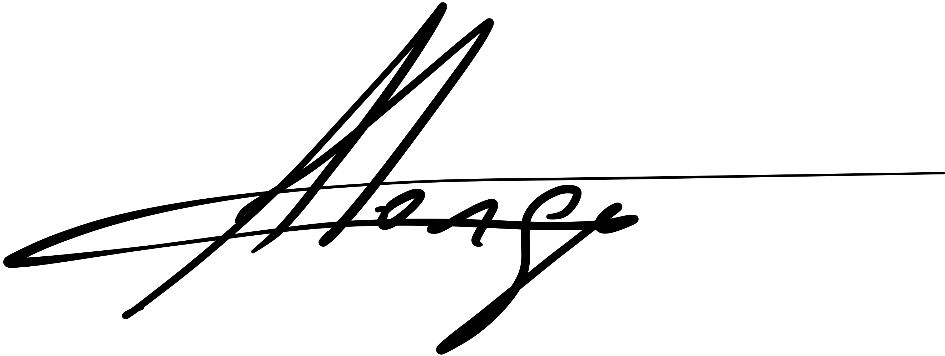

Arnold Jorge
Chief Executive Officer
Export Council of Australia
M: 0424191311

https://www.hinrichfoundation.com/research/article/ftas/international-trade-agreements/
Size of business is based on number of employees. https://www.asbfeo.gov.au/small-business-data-portal/number-small-businesses-australia. https://www.abs.gov.au/statistics/economy/international-trade/characteristics-australian-exporters/2019-20#methodology
https://unctad.org/news/global-trade-slows-green-goods-grow
https://www.bcg.com/press/12january2023-growing-green-market-demand-provides-opportunities-for-early-movers

