21 December 2022

Joint Standing Committee on
Trade and Investment Growth
Committee Secretariat
PO Box 6021
Parliament House
CANBERRA ACT 2600

Inquiry into Australia's transition to a green energy superpower

Introduction

The Export Council of Australia (ECA) welcomes the opportunity to submit its views on Australia becoming a green energy superpower.

We are supportive of this initiative as global conditions and market demand in the mid to longer term are likely to substantiate investments in this space. Australian exporters involved in green energy have the potential to tap into this global growth.

As a peak industry body representing Australian exporters, including small and medium sized enterprises (SMEs) engaged in environmental sustainability and green energy, our submission focuses on enabling these businesses to compete successfully in international markets.

From an international trade perspective, this will require among other things the promotion of Australia’s brand overseas, creating market access opportunities (including through innovative trade agreements), building knowledge and skills on exporting, and business matching.

These must be augmented by domestically orientated initiatives, such as increased availability of finance for growth, investments in infrastructure, clear policy settings and supportive programs, and coordinated approach between federal and state governments, as well as across government agencies.

A great starting point

Australia has good foundations to becoming a green energy superpower, including recent notable shift towards renewable energy investments, having been endowed with natural resources and critical minerals, a strong R&D base, and innovative entrepreneurs and businesses.

But the world’s transition to green energy will be the consequential driver, with expected global demand to rise significantly in the coming decade. Australia is also making the change – with more than 30 per cent of Australia’s electricity now coming from “clean energy sources”.

As additional investments are made into renewable energy projects (here and overseas), these can spur the development of sovereign (Australian) technologies and manufacturing capacity, up and down the supply chain.

To be a true green energy superpower, Australia must therefore not only rely on its natural resource endowments, it must also have the associated technological and manufacturing capability, and skills and know-how.

Australia must be able to produce the hardware, equipment, and services necessary to generate and deliver clean electricity. These can come from various industries and through various activities or solutions.

For example, with the high growth of small-scale renewable energy generation in Australia (such as household rooftop solar panels), we (Australia) should have simultaneously built capacity to manufacture ‘advanced’, efficient and affordable solar panels. At this time, however, we understand that there are only two solar panel manufacturers in Australia, and the market is dominated by China and Germany.

The use of solar panel for electricity generation, could be optimized by pairing it with battery storage. Batteries are of course also used for other purposes, such as for electric vehicles. There is merit for the development of a battery industry here in Australia. There are indications of Australian innovations, including by a recent start-up that the uses zinc-bromide (rather than lithium) for a safer, longer-lasting, cheaper, and environmentally-friendly batteries.

As more and more cities seek to reduce their carbon footprint, they are seriously looking at small scale renewable energy generation, as part of a diversified, decentralized and yet interconnected sources of energy and electricity generation.

In this context, again Australia has a potential solution.

An Australian business has an energy management system that allows clean energy producers to feed multiple times more energy back into existing electricity grids, through an advanced power electronics device and energy software.

The SMEs mentioned previously (i.e. solar manufacturer, battery start-up, and energy systems management) are just a few examples of the range of Australian capabilities that could enhance its green energy superpower credentials. They are ventures that have potential for significant growth beyond Australian shores.

Enhancing the journey ahead

But how do we ensure such innovations are successfully commercialized or grow to meet international market demand?

From an international trade standpoint, we believe there are five key areas that will require attention:

- Market intelligence and business matching – Having a sense of where the opportunities are, will assist SME exporters with their analysis and allow for more efficient, if not targeted, preparations. Advanced information, such as on market direction, or potential demand and new projects would be useful. Austrade’s overseas network will have an important role to play, but it must have the capacity and capability to share that intel with relevant Australian exporters, and help them find suitable partners.

- Branding – Trade partners overseas must consider Australian exporters involved in green energy as the preferred suppliers. They must perceive Australian goods and technologies as being well-engineered, and services delivered as both competent and responsive. Customers must see Australia’s offerings as consistent with its broader value and reputation as a champion for the environment. The marketing of Australia’s credentials in green energy must be strategic and should commence immediately.

- Market access – In recent times, Australia has negotiated innovative bilateral and regional trade agreements, such as the Singapore-Australia Green Economy Agreement. Such deals help open markets and facilitate trade in environmental goods and services, including by having consistent regulations and standards across partner countries, and building goodwill through grant funding of joint projects. Similar agreements must be pursued or extended to other parties.

- Export-ready skills – While there are many innovative Australian businesses involved in green energy at the domestic level, expansion of their activities and operations offshore will require a different skill-set. They may have to navigate different regulatory approval processes and consider alterative market entry methods, such as licensing, which may alter their business models. International trade awareness training should be offered to those businesses involved in green energy, especially start-ups.

- Export finance – Private capital and investment in green energy is growing, but there remain gaps. For example, there are limited financial products targeted at smaller businesses/exporters in green energy related ventures. This may, in part, be due to the lack of environmental knowledge and expertise of individuals in the financial sector. This is exacerbated by the lack of sophistication among smaller businesses/exporters about the range of funding they could access. There is an opportunity for Export Finance Australia to take leadership and develop funding support that is especially targeted at green energy exporters in their early stages of their journey (including start-ups).

To address the above issues effectively, the government must put in place the appropriate mix of policies and programs. These must be sufficiently funded, and closely involve the private sector.

These trade-related efforts must also be complemented by domestically orientated initiatives, including policy leadership that encourages further investments in green energy, better coordination between federal and state governments (as well as across government agencies), and upgrades to relevant infrastructure.

Conclusion

The window of opportunity for Australia to position itself as a green energy powerhouse is likely to be short. To achieve it will require real and substantial commitment from all parties, and must move with pace and purpose. There will be risks and subsequent costs, which the government must prepare for. But the rewards can be substantial – not just from a commercial standpoint, but for the future of the planet.

We would be pleased to elaborate on the above, and look forward to engaging with the Committee on its work ahead.

About the Export Council of Australia (ECA)

We are the peak body representing every player in the ecosystem of international trade. ECA members are individuals, small, medium and large enterprises, coming from different industries and sectors. Our exporter members do business in markets across the globe. Our services include provision of advice, training, ecosystem building, and advocacy. We focus on advancing issues that have impact at scale, including on technology and trade, reliable and affordable shipping, simplified trade and traceability, Indigenous and environmental issues.

Yours sincerely

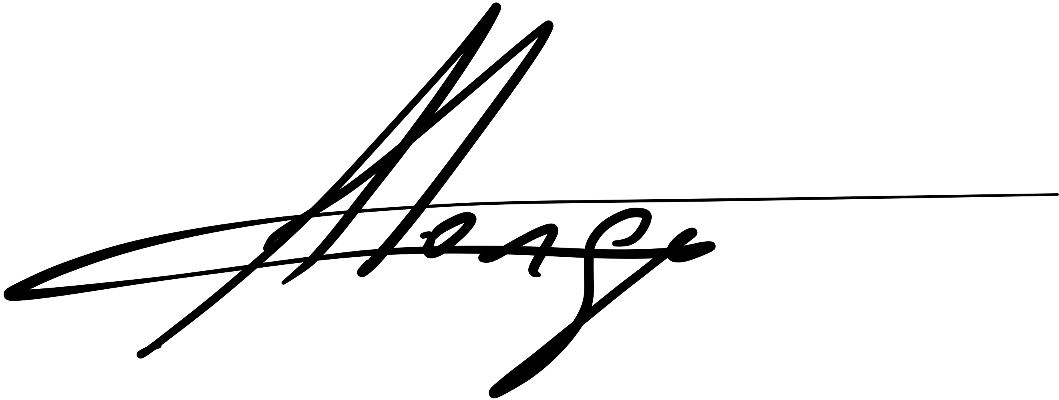

Dianne Tipping Arnold Jorge
Chair of the Board of Directors Chief Executive Officer
Export Council of Australia Export Council of Australia
M: 0418444319 M: 0424191311

https://www.ga.gov.au/scientific-topics/energy/resources/other-renewable-energy-resources
https://www.globenewswire.com/en/news-release/2022/10/05/2528569/0/en/Global-Renewable-Energy-Market-Size-to-grow-USD-1930-6-Billion-by-2030-CAGR-of-8-5-Spherical-Insights-Consulting.html
https://assets.cleanenergycouncil.org.au/documents/resources/reports/clean-energy-australia/clean-energy-australia-report-2022.pdf
https://www.rba.gov.au/publications/bulletin/2020/mar/renewable-energy-investment-in-australia.html
https://www.energy.gov/eere/solar/articles/should-i-get-battery-storage-my-solar-energy-system
https://www.theguardian.com/environment/2021/nov/25/real-beacon-battery-tech-company-lists-on-uk-market-in-first-for-university-of-sydney
https://www.irena.org/publications/2020/Oct/Rise-of-renewables-in-cities
https://arena.gov.au/news/utilising-technology-to-increase-distributed-energy-in-low-voltage-networks/
https://www.iea.org/reports/world-energy-investment-2022/overview-and-key-findings
https://www.pv-magazine-australia.com/2022/10/28/report-finds-sustainability-skills-gap-in-australian-financial-sector/

